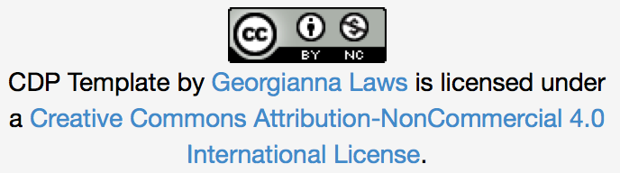

Interactive Table of Contents
Part 1: Course Information • Part 2: Course Development Plan

Part 1: Course Information

NOTE: For existing courses, please provide information that matches language from the corresponding curriculum form and course catalog listing.

- Host college:
- Host department:
- Course development team:
  - Faculty developer/subject matter expert:
  - Instructional designer/pedagogy expert:
  - Other stakeholders/their roles:
- Course prefix, number, and title:
- Course format:
☐ fully face-to-face
☐ face-to-face & online mix
☐ fully online
- Credit hours:
- Prerequisite(s):

>> Continued on the next page.

- Course description:
- Course-level goal(s):

- Course-level outcomes:

- Certificate- or program-level outcomes that this course must satisfy (and at what level):

Part 2: Course Development Plan

Before you begin filling out the course development plan, please read the instructions. Top

Module | Week | Outcomes | Instruction | Learning Activities
1
2
3

>> Continued on the next page.

Module | Week | Outcomes | Instruction | Learning Activities
4
5
6

>> Continued on the next page.

Module | Week | Outcomes | Instruction | Learning Activities
7
8
9

>> Continued on the next page.

Module | Week | Outcomes | Instruction | Learning Activities
10
11
12

>> Continued on the next page.

Module | Week | Outcomes | Instruction | Learning Activities
13
14
15

